SIMPLILEARN Full Stack Developer - MERN Stack Masters Program
Course – 3 Design a Dynamic Frontend with React
Assessment – Screenshots for Project Implementation
Student Name : Vedaang Sharma

- Login Page
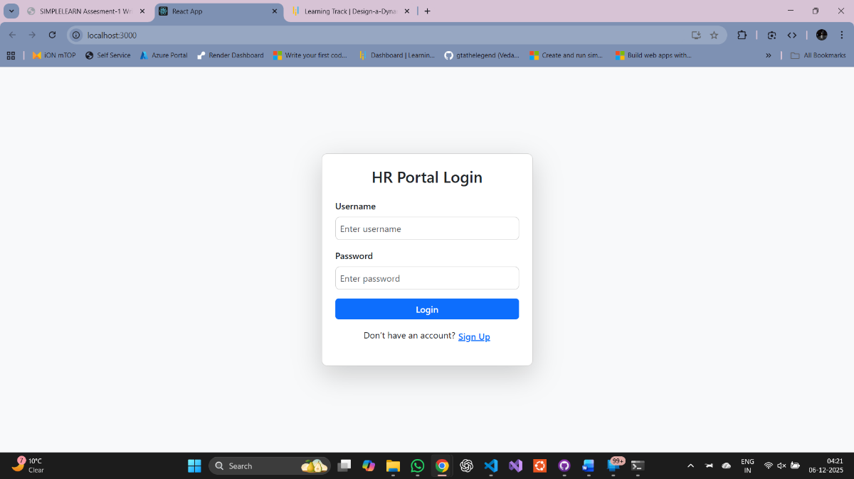

- Sign Up New User as HR
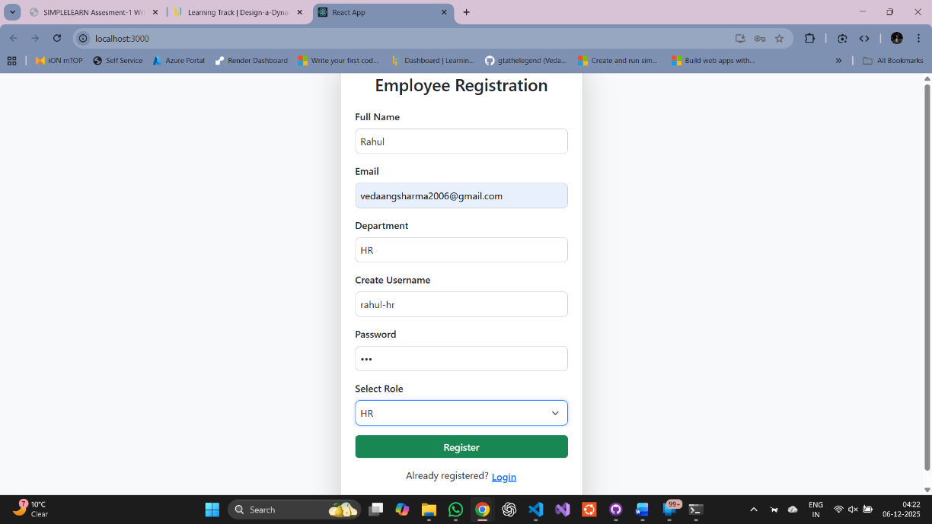

- Signup Success
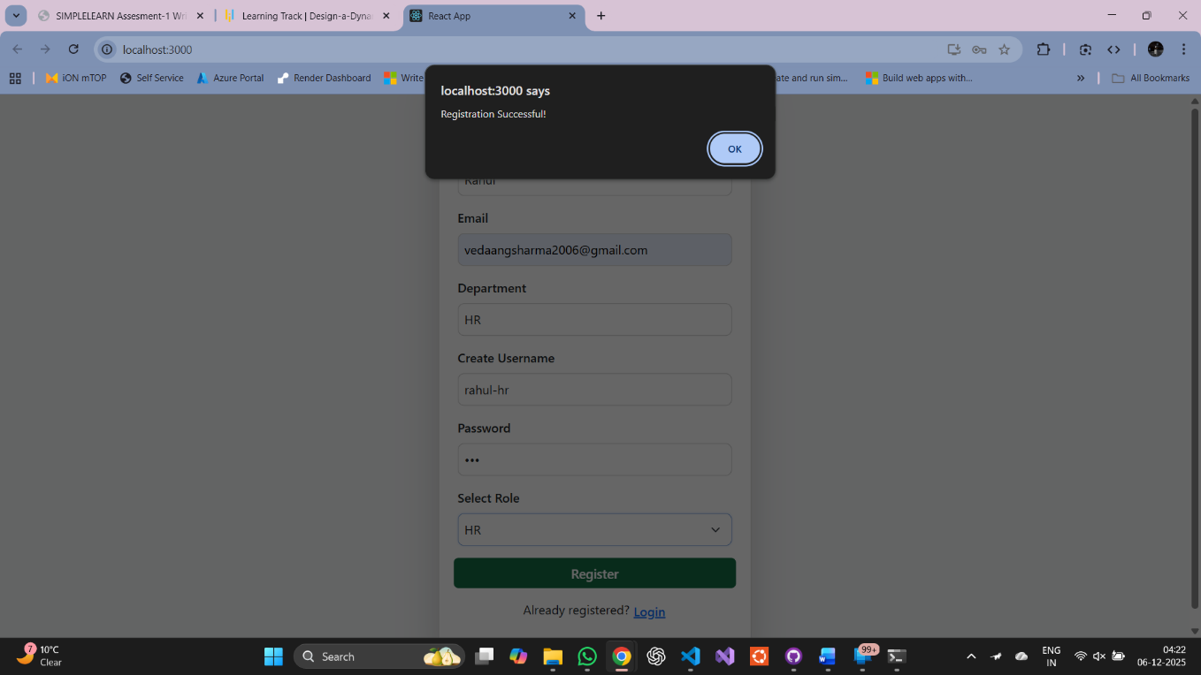

- HR Dashboard

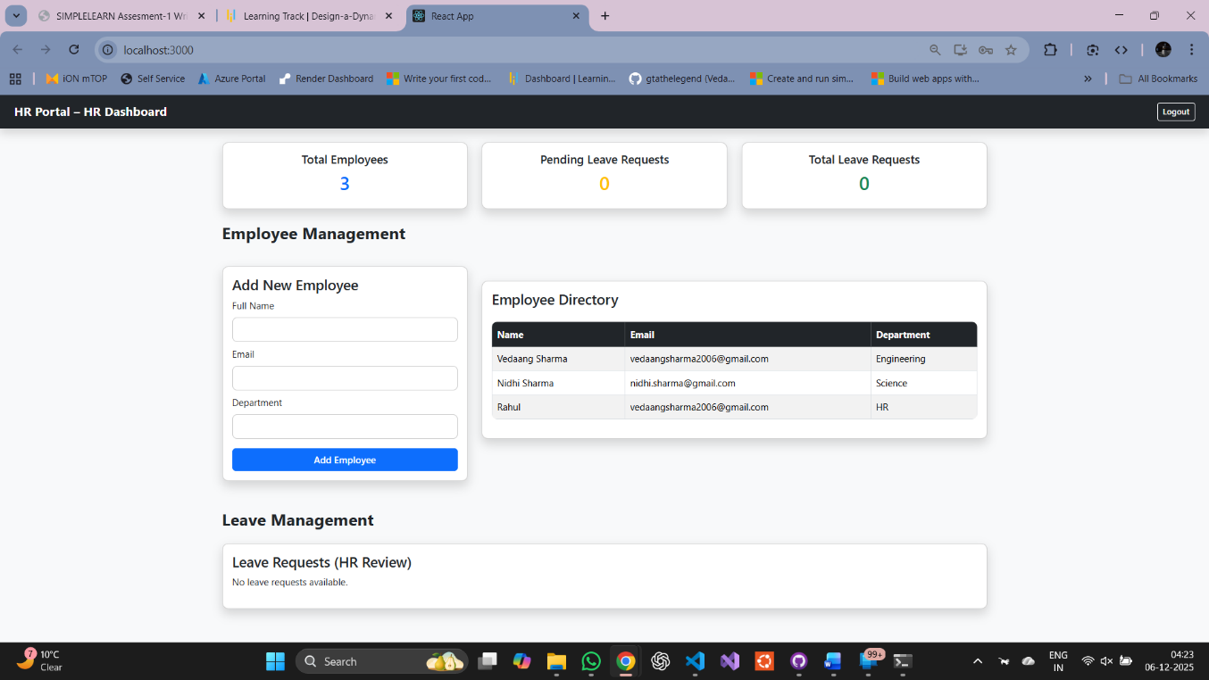

- Add Employee from HR Dashboard
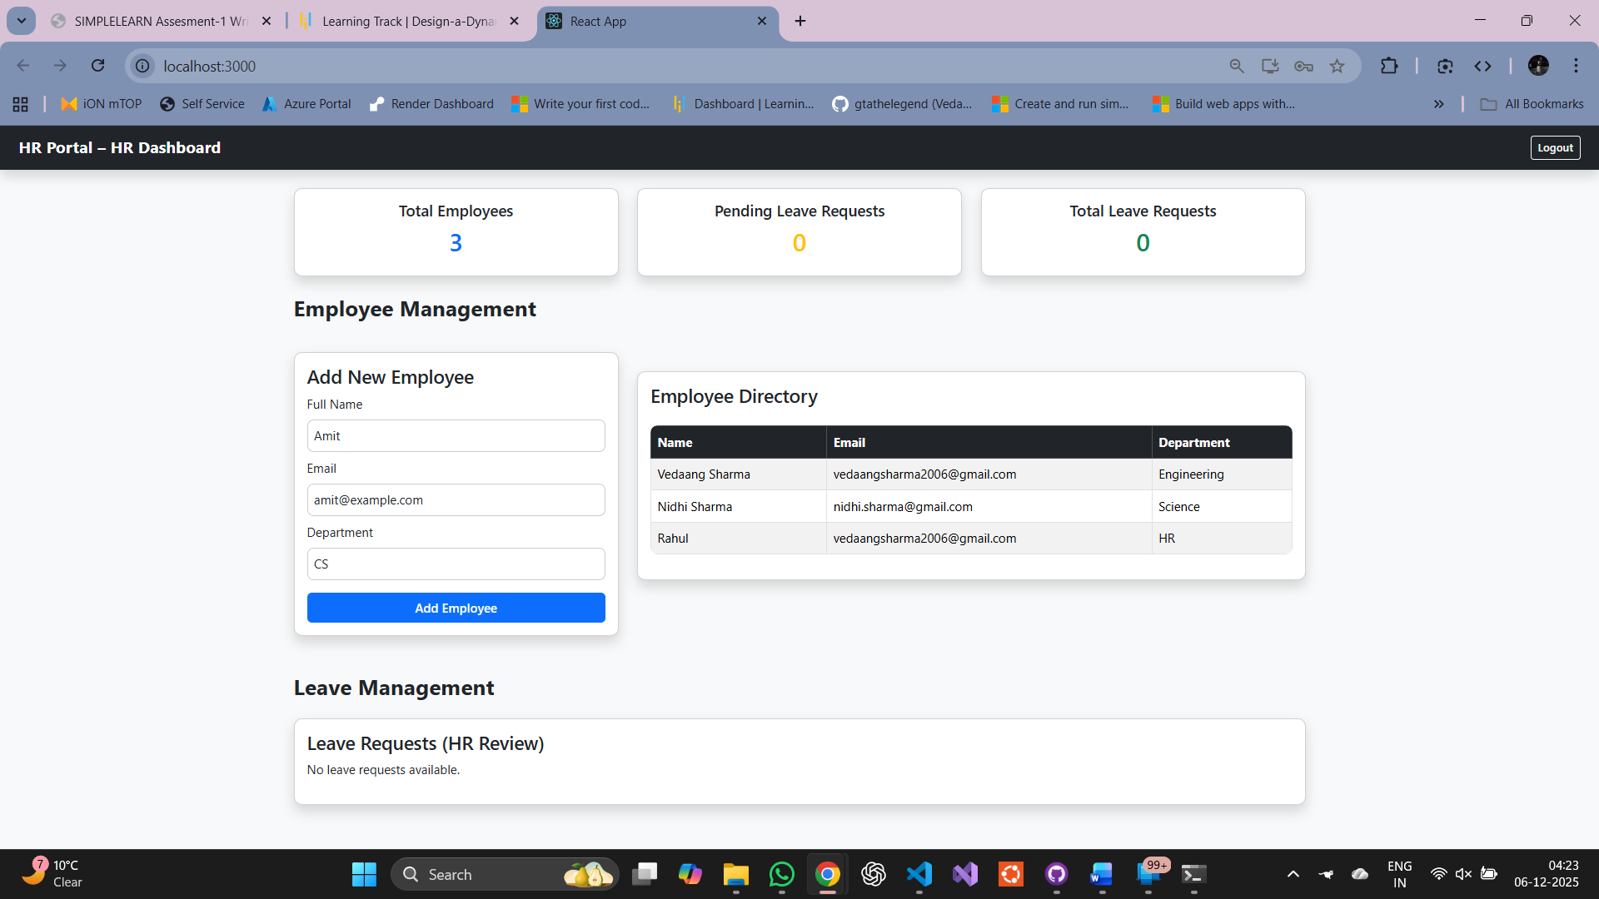

- Employee Added from HR Dashboard
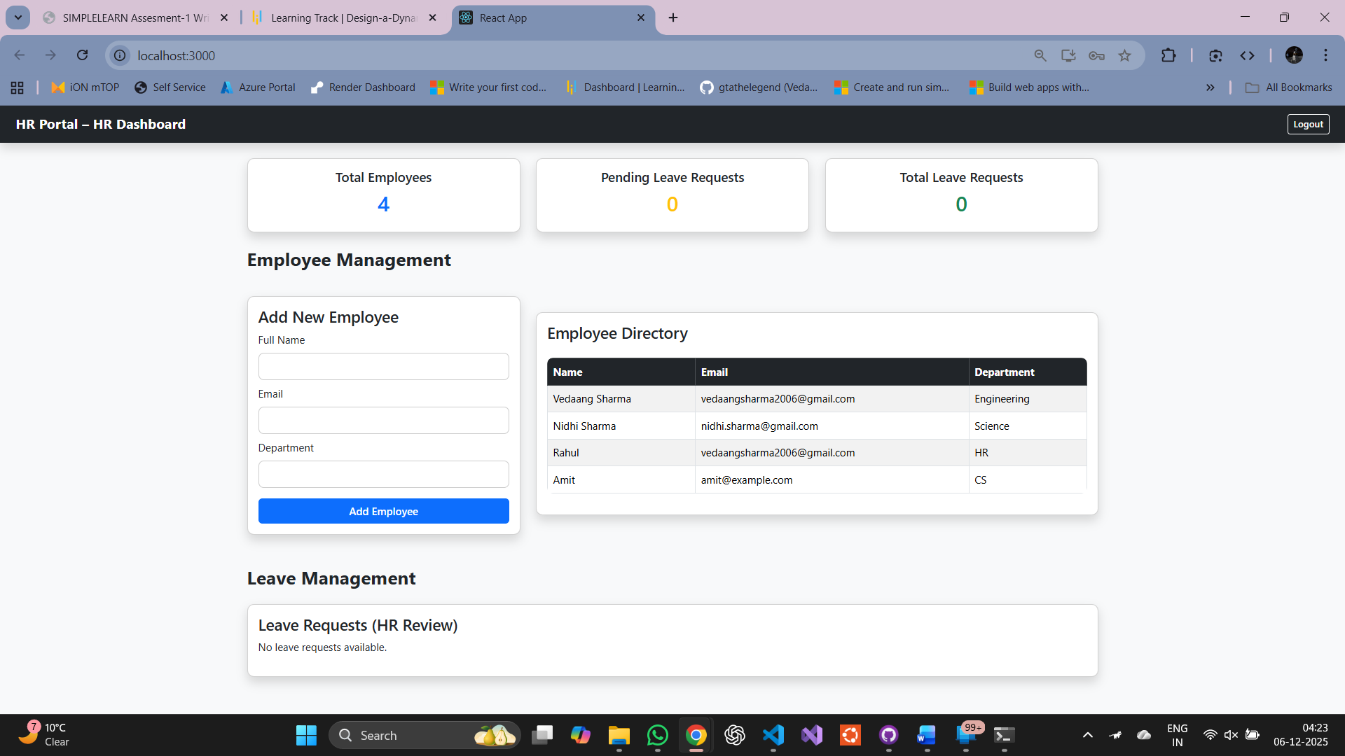

- Sign Up User as Employee
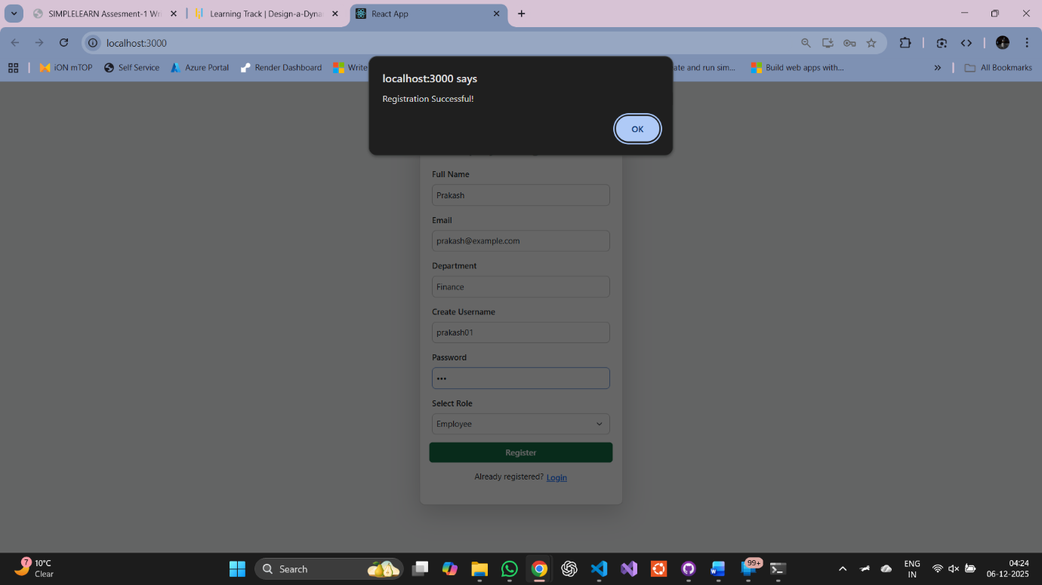

- Employee Dashboard
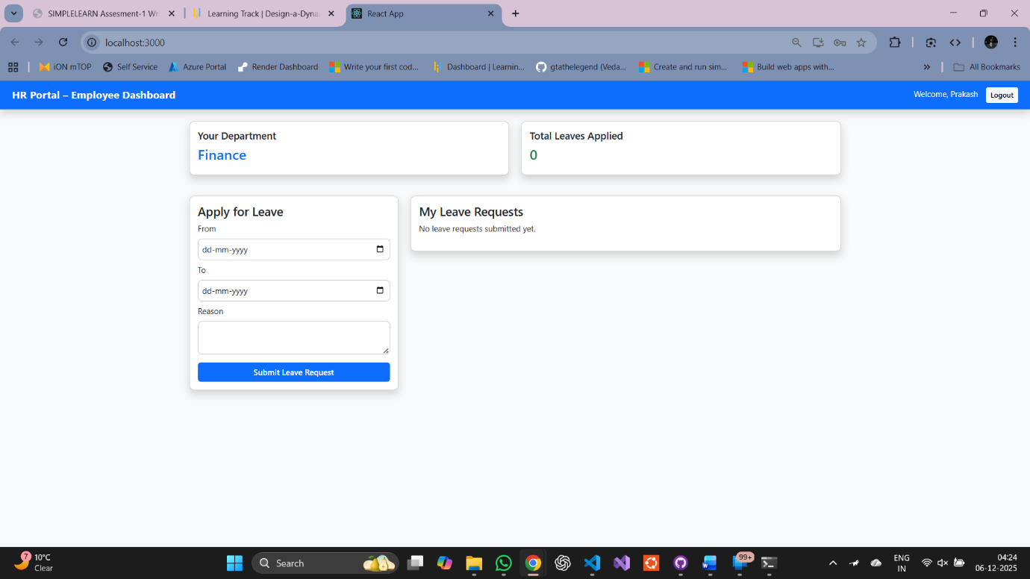

- Apply Leave from Employee Dashboard
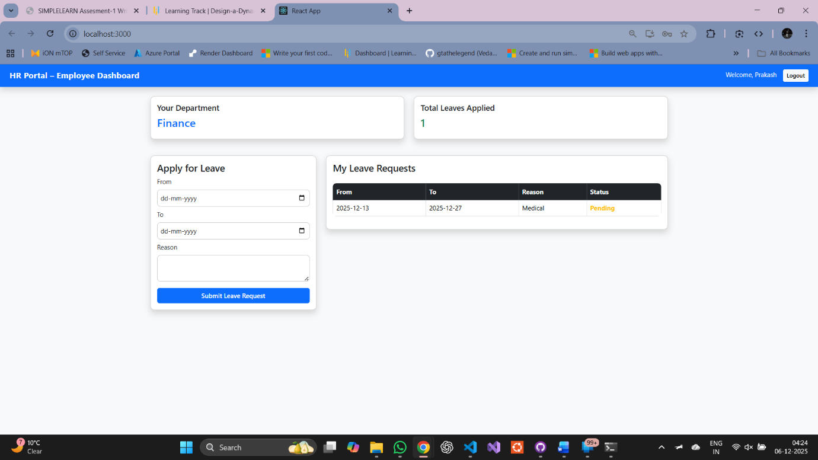

- Approving Employee Leave Request from HR Dashboard
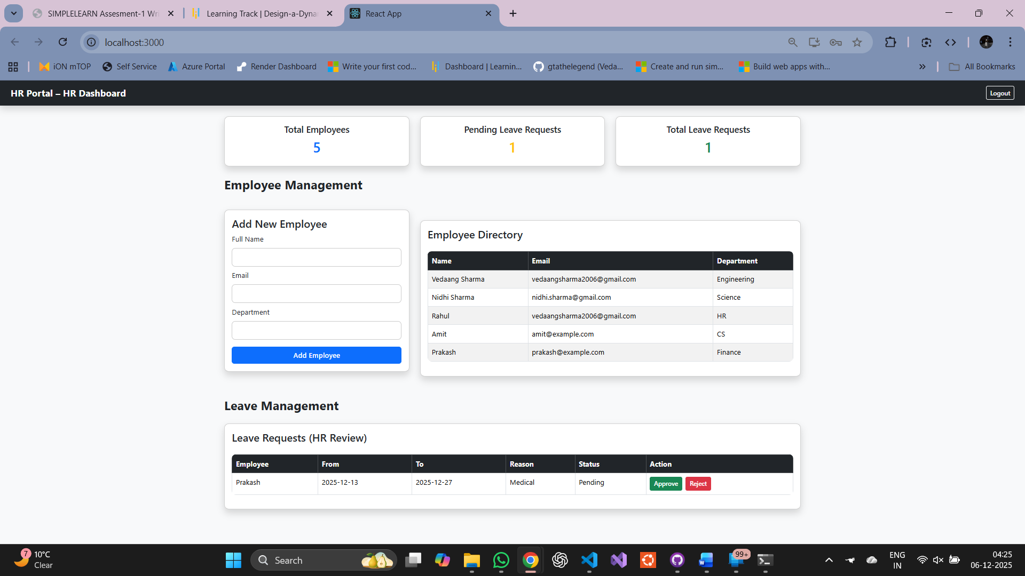

- Approved Leave Request for Employee
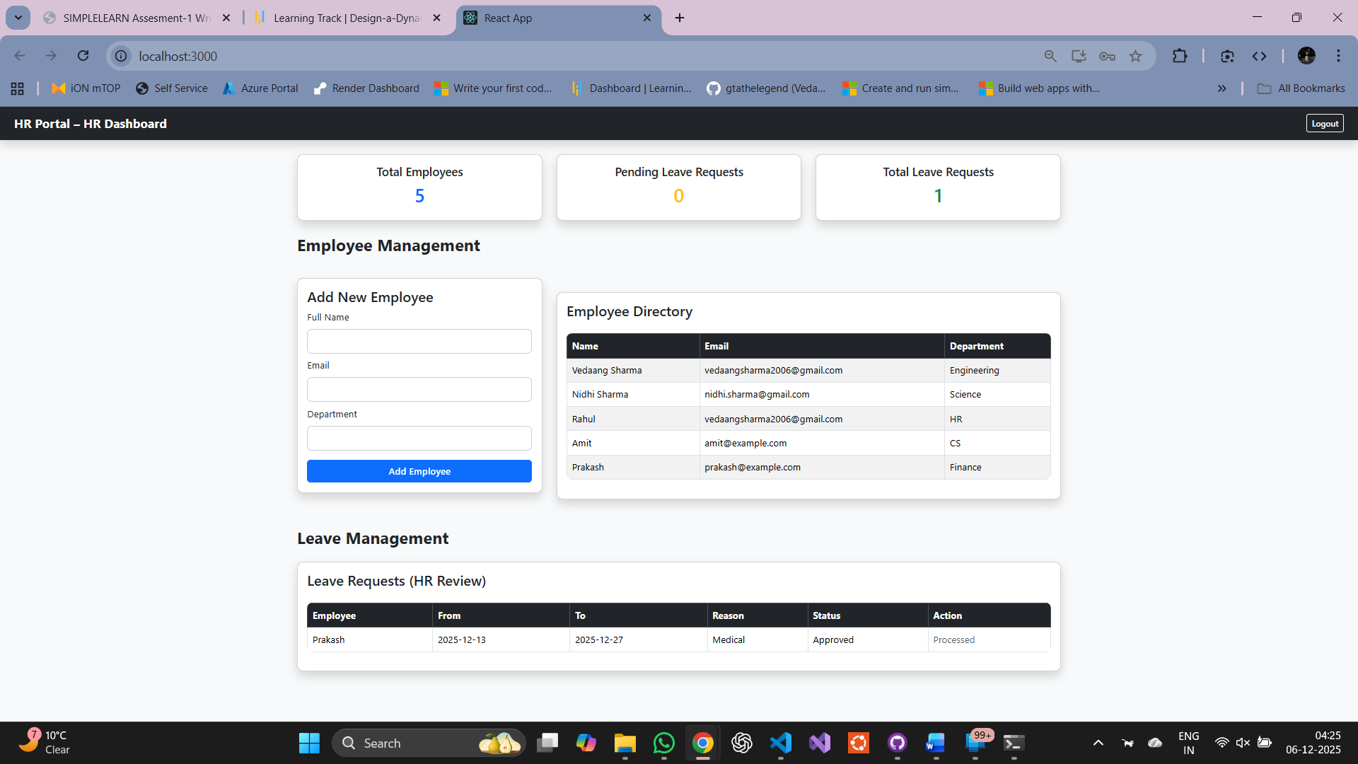

- Leave Status Approved on Employee Dashboard
